ONLINEQUIZSYSTEM
APROJECT REPORT
Submitted by
23BCS10738(GARIMA)
23BCS11999(RIYA SINGH)
23BCS12491(TANISHK THAKUR)
inpartialfulfillmentfortheawardofthedegree of

BACHELOROFENGINEERING
IN
COMPUTER SCIENCE & ENGINEERING

Chandigarh University
NOV, 2025

TABLE OF CONTENTS
CHAPTER1. INTRODUCTION.......................................................................... 4
1.1. Introduction to Project.......................................................................................................4 1.2. Identification of Problem...................................................................................................5
CHAPTER3. DESIGNFLOW/PROCESS..........................................................6
2.1 Evaluation & Selection of Specifications/Features............................................................6
2.2 Analysis of Features and finalization subject to constraints............................................11
2.3 Design Flow.....................................................................................................................14
CHAPTER3. RESULTS ANALYSIS AND VALIDATION............................15
3.1 Implementation of solution..............................................................................................15
CHAPTER4. CONCLUSION AND FUTURE WORK....................................19
4.1 Conclusion.......................................................................................................................19
4.2 Future work..................................................................................................................... 20
References.................................................................................................................................22

CHAPTER 1: INTRODUCTION
1.1 Introduction to Project
In today’s fast-paced digital world, quizzes have transformed from traditional paperbased assessments to interactive, instant, and engaging tools used in a wide range of domains. Whether it is in educational institutions for evaluating student performance, in companies for employee training and certification, or on online platforms for personal learning and entertainment, quizzes serve as an effective way to test knowledge, enhance learning retention, and measure understanding. With the rise of online learning platforms, e-examinations, and virtual classrooms, the need for efficient, scalable, and user-friendly quiz systems has become more crucial than ever.
The Online Quiz System developed using Java is a practical solution that addresses this growing demand. It is a lightweight, offline-capable application designed to deliver quiz functionality in both console-based and optionally graphical user interface (GUI) formats. This project is primarily aimed at demonstrating and applying essential programming concepts such as Object-Oriented Programming (OOP), arrays, file handling, and user interaction in Java. It provides a real-world example of how theoretical concepts can be effectively combined to build a working system that serves both educational and practical purposes.
The core of the system is built around dynamically loading quiz questions from an external file, allowing for complete flexibility in managing the question bank. Each question, along with its options and correct answer, is represented as an object of a Question class, which is then stored in a structured collection like an ArrayList. This modular design ensures easy modification and scalability, as new questions can be added or existing ones edited without modifying the application logic.
Once the quiz begins, users interact with the system by reading questions one at a time and selecting their answers. As each response is entered, the system immediately compares it with the correct answer and updates the score. This real-time evaluation model makes the experience interactive and informative, providing instant feedback at the end of the quiz in the form of scores and performance summaries. Such instant feedback not only enhances the learning experience but also encourages users to reflect on their knowledge gaps and areas for improvement.
An important advantage of this system is its offline capability. Unlike many commercial quiz platforms that require continuous internet connectivity, this system can be run on any device that has a basic Java environment, making it suitable for low-resource environments such as rural schools, offline coaching centers, or home study. Additionally, being platform-independent, the system can operate on Windows, Linux, or macOS without any compatibility issues.
For developers and learners, this project acts as an excellent starting point to explore Java development. It covers a wide range of foundational topics such as class creation, control structures, user input, file reading/writing, exception handling, and optionally GUI development using Java Swing. Those interested in extending the application can enhance it with features such as a timer, login system, graphical score charts, question randomization, and even database integration for persistent storage.
In summary, the Online Quiz System in Java is not just a simple application—it is a flexible and educational tool designed to meet the needs of modern learners and developers. It exemplifies how core programming concepts can be applied to create a real-world solution that is adaptable, easy to use, and educationally valuable. Whether used for learning Java, building academic projects, or providing basic quiz functionality in classrooms, this project offers a meaningful demonstration of software development with practical impact.
1.2 Identification of Problem
In conventional educational settings, administering quizzes and assessments is a labor-intensive and time-consuming process. Educators are tasked with designing questionnaires, producing physical copies, distributing them to students, overseeing the examination process, collecting completed papers, and manually evaluating each response. This traditional approach is not only inefficient but also prone to human errors, misplacement of documents, and delays in result dissemination. The challenges are further exacerbated when managing large groups, where logistical complexities and resource constraints become significant hurdles.
The advent of digital education, accelerated by the shift towards remote learning and virtual classrooms, underscores the necessity for automated quiz systems that are user-friendly, accessible, and efficient. While several online platforms like Google Forms, Kahoot, Quizizz, and Socrative offer quiz functionalities, they often come with limitations. These platforms typically require constant internet connectivity, user registrations, and involve intricate setup procedures. Moreover, being proprietary, they do not provide access to their underlying codebases, restricting learners and developers from exploring or customizing the systems to suit specific educational needs.
This lack of transparency and flexibility poses a significant challenge for computer science students and novice programmers who seek to learn through practical, handson projects. Academic curricula often mandate the development of software solutions from the ground up to demonstrate a comprehensive understanding of programming concepts. Developing a quiz system, albeit seemingly straightforward, necessitates the integration of various fundamental principles such as object-oriented programming (OOP), array manipulation, file input/output operations, control structures, and user interaction handling. The incorporation of a graphical user interface (GUI) adds another layer of complexity, requiring proficiency in Java Swing or JavaFX.
Beginners frequently encounter difficulties in amalgamating these components into a cohesive and functional application. Challenges include managing file structures, validating user inputs, storing and comparing answers, and accurately displaying results. These obstacles can impede the learning process and deter students from fully engaging with the practical aspects of software development.
To address these issues, this project presents a lightweight, self-contained, and fully customizable Online Quiz System developed using core Java. The system operates independently of external tools or internet connectivity, granting users complete control over question formats and enabling modifications to align with specific academic or personal requirements. By bridging the gap between theoretical knowledge and practical application, this project facilitates the transition from conceptual understanding to real-world software development, empowering learners to build, adapt, and enhance their own educational tools.

CHAPTER 2: DESIGN FLOW/PROCESS
2.1 Evaluation & Selection of Specifications/Features
Before beginning development, it was important to identify and evaluate the core specifications and features that the Online Quiz System should support. The project was aimed at being lightweight, offline-compatible, and educational, making it ideal for classroom use, personal learning, or as a beginner-friendly Java project. Several factors were considered while selecting the specifications, such as the complexity of implementation, clarity of output, ease of user interaction, and potential for future upgrades. Based on these considerations, the following features and technologies were finalized:
- Chosen Programming Language: Java
Java was selected as the programming language for implementing the Online Quiz System due to its versatility, robustness, and platform independence. As a high-level, object-oriented language, Java offers a clear syntax and strong support for modular programming, which makes it an excellent choice for educational projects. The language provides built-in support for essential features such as file handling, arrays, exception management, and user input, all of which are crucial to the functionality of a quiz system. Java’s “write once, run anywhere” capability ensures that the application can be executed on any operating system equipped with the Java Runtime Environment (JRE), increasing its accessibility and deployment flexibility.
Additionally, Java encourages the use of reusable classes and objects, making it easier to maintain and expand the codebase. The integration of graphical user interfaces through Java Swing or JavaFX also opens up possibilities for enhancing the user experience in future versions of the system. For beginner to intermediate-level developers, Java strikes a balance between ease of learning and powerful capabilities, which aligns well with the educational intent of the project. Overall, Java’s wide community support, extensive documentation, and comprehensive libraries make it a reliable and effective language for developing a simple yet functional Online Quiz System.
- File Input/Output (File I/O)
File Input/Output (File I/O) plays a crucial role in the Online Quiz System by enabling dynamic storage and retrieval of quiz questions and answers. Instead of hardcoding the quiz content within the program, the system uses external text files to store multiplechoice questions along with their options and correct answers. This approach makes the system more flexible and easily maintainable, as quiz content can be modified or extended without altering the source code. Java's standard java.io package provides classes like FileReader, BufferedReader, and File to handle reading data from files efficiently.
During program execution, the file is read line by line, and each question is parsed and stored in an array or object structure for easy access. This modular design allows users or educators to update the quiz by simply editing the text file, making the system customizable for different subjects, topics, or difficulty levels. In addition to reading from files, the system can also be extended to write user scores or feedback to external files, thereby maintaining records for future reference. File I/O not only enhances the usability of the quiz system but also introduces students to an essential real-world concept of persistent data handling in Java.
- Object-Oriented Approach
The Online Quiz System is developed using an Object-Oriented Programming (OOP) approach, which enhances code organization, readability, and scalability. The system is structured around real-world entities, where classes represent the core components of the quiz such as Question, QuizManager, and User. Each class encapsulates its own data and behavior, promoting modularity and separation of concerns. For instance, the Question class holds the question text, options, and correct answer, while the QuizManager class is responsible for managing the quiz flow, user input, and score calculation.
Key OOP principles like encapsulation, abstraction, and reusability are applied throughout the project. Encapsulation ensures that data is protected and accessed only through defined methods, reducing the chances of errors. Abstraction allows the user to interact with the system without needing to understand the internal complexities. Reusability is achieved by designing generalized methods and components that can be used in future upgrades or other applications. By following the OOP paradigm, the project not only becomes easier to understand and debug but also provides a solid foundation for learners to grasp how large-scale software systems are built using Java.
- Array/ArrayList for Question Storage
In the Online Quiz System, questions and their associated options are stored using either arrays or the more flexible ArrayList data structure in Java. Arrays provide a fixed-size, indexed collection of elements, suitable for storing a known number of questions. However, to improve scalability and ease of data manipulation, ArrayList is often preferred due to its dynamic size and built-in methods for adding, removing, and accessing elements. Each quiz question is represented as an object, typically of a Question class, and these objects are stored within an ArrayList<Question> to allow efficient iteration and management.
The use of ArrayList ensures that the system can handle quizzes of varying lengths without requiring predefined limits. It also simplifies the process of loading questions from an external file, as each new question can be added dynamically as the file is read. This approach enhances the flexibility and robustness of the application, making it easy to expand or modify the quiz content as needed. Whether using arrays or ArrayList, the choice of structured storage ensures organized access to questions, enabling the quiz to flow smoothly and reliably for the user.
- Console-Based Interface (Initial Version)
The initial version of the Online Quiz System is implemented using a console-based interface, which provides a simple yet effective way for users to interact with the application. The console interface displays each quiz question along with multiplechoice options, and the user is prompted to enter their response by selecting the correct option number. This approach ensures minimal system resource usage and keeps the focus on core functionalities such as input handling, question display, score tracking, and file reading. Despite its simplicity, the console-based interface is highly functional and user-friendly. It guides the user step-by-step through the quiz and provides realtime feedback by calculating the score at the end of the session. Basic input validation is incorporated to ensure users enter only valid responses, preventing the program from crashing due to unexpected inputs. The decision to use a console interface in the initial version helps maintain clarity and encourages a deeper understanding of Java fundamentals like loops, conditionals, and I/O operations without the added complexity of GUI development.
Furthermore, this foundational version lays the groundwork for future enhancements. Developers can later extend the same logic to a graphical interface using Java Swing or JavaFX, building upon the already robust and modular codebase. Overall, the console-based design strikes an ideal balance between functionality and simplicity, making it a perfect starting point for both learning and practical demonstration.
- Score Tracking
Score tracking is a core component of the Online Quiz System, providing users with immediate feedback on their performance. As the quiz progresses, the system evaluates each response in real time and keeps a cumulative record of correct answers. This is typically implemented using a simple integer counter that increments whenever the user selects the correct option. At the end of the quiz, the total score is calculated and displayed along with a percentage, giving the user a clear understanding of their performance. The score tracking logic is tightly integrated with the main quiz flow, ensuring that evaluation occurs instantly after each response. Additionally, the system can be extended to offer more detailed feedback, such as highlighting incorrect answers or providing explanations for correct ones. This functionality is not only useful for assessment but also promotes learning and selfimprovement. In future versions, the score tracking mechanism can be enhanced to maintain historical records by writing scores to a file, generating reports, or even offering rank-based evaluations.
Overall, the score tracking system is efficient, accurate, and easy to implement, serving as both a motivator for users and a foundation for further analytical features. It plays a vital role in the usability and effectiveness of the quiz system by making results transparent and instantly available.
- Optional GUI Extension
To enhance the user experience and make the Online Quiz System more visually engaging, a graphical user interface (GUI) can be optionally implemented using Java Swing. While the initial version is console-based for simplicity and clarity, the GUI extension adds a professional touch and introduces students to Java's event-driven programming model. Swing provides a rich set of components such as JFrame, JLabel, JButton, and JRadioButton, which can be used to create windows, display questions, and capture user responses in a visually intuitive manner. The GUI version allows for better layout management, clear navigation between questions, and real-time display of scores in a more user-friendly format. It also supports error messages, option highlighting, and confirmation dialogs, which contribute to a more polished and interactive user interface. Implementing a GUI introduces important programming concepts like action listeners, layout managers, and component hierarchy, thereby deepening the developer’s understanding of Java.
Moreover, the GUI can be further enhanced with features like timers, progress bars, animations, and themes, offering a foundation for creating more advanced educational software. While not mandatory, the GUI version showcases the system’s adaptability and provides an excellent opportunity for learners to bridge the gap between logic implementation and user experience design.
- Platform & Tools
The Online Quiz System was developed using the Java programming language due to its platform independence, object-oriented structure, and rich standard library support. Java provides essential tools for building both console-based and GUI-based applications, making it an ideal choice for educational software projects. The development environment used was Visual Studio Code, which offers a clean interface, extension support, and integrated terminal for compiling and running Java programs efficiently. Additionally, the system utilizes Java Development Kit (JDK) for compiling and executing the Java code.
For file handling and text-based question storage, standard Java I/O packages were employed, ensuring compatibility across all major operating systems such as Windows, macOS, and Linux. In GUI implementations, the Swing framework was used to build interactive components and manage user events. Version control tools like Git can also be integrated into the workflow to track changes and collaborate on future enhancements. Overall, the selected platform and tools provide a lightweight, efficient, and flexible development setup that supports both beginners and intermediate-level developers in building robust Java applications.
2.2 Analysis of Features and Finalization Subject to Constraints
After selecting the initial set of features and technologies, the next step involved analysing them in terms of feasibility, performance, and limitations. This phase ensured that only the most suitable and implementable features were finalized, based on constraints such as time, system resources, project scope, and learning objectives.
Each proposed feature was evaluated against the following constraints:
- Time Constraint
During the development of the Online Quiz System, several constraints influenced the design choices and scope of implementation. One of the most significant constraints was time. The project had to be completed within a limited academic schedule, which meant that only core functionalities could be developed and tested thoroughly. As a result, optional features such as a graphical user interface (GUI), database connectivity, or advanced customization had to be postponed or simplified. Another constraint was the technical complexity involved in integrating multiple Java features cohesively. Since the project aims to demonstrate foundational Java concepts like Object-Oriented Programming, arrays, and file handling, the focus remained on ensuring these elements were correctly implemented without overwhelming the structure. Introducing too many advanced modules within the limited timeframe could have compromised the clarity and stability of the program. Furthermore, platform dependency was also considered. The project runs using Java, which requires the Java Runtime Environment (JRE) to be installed on the user’s system. While Java is widely supported, this still creates a minor limitation for users unfamiliar with setting up Java environments. Additionally, due to the use of plain text files instead of a proper database system, the system may face challenges when dealing with very large datasets or when used in multi-user environments.
Lastly, usability was slightly limited due to the console-based interface. While functional, it may not offer the best user experience for all users. A GUI could make the system more interactive and user-friendly, but given the constraint of time and the educational focus of the project, the console version was prioritized.
- Simplicity vs. Functionality
A key consideration throughout the development of the Online Quiz System was maintaining a balance between simplicity and functionality. Since the primary goal of the project was to demonstrate core Java concepts in a clear and educational manner, the system was intentionally designed to be straightforward and easy to understand. This meant avoiding overly complex structures, advanced libraries, or heavy dependencies that could distract from the learning objectives. However, this simplicity came at the cost of excluding certain advanced features such as real-time data tracking, adaptive quizzes, user authentication, and in-depth analytics. While it is possible to implement a feature-rich quiz system, doing so within a limited timeframe and while ensuring clarity for beginner programmers posed a challenge. Therefore, decisions were made to prioritize essential functionalities like question loading from files, score calculation, and real-time feedback, while leaving room for future enhancements. The system provides just enough functionality to be useful and interactive, without becoming too complicated for a beginner to explore, modify, or extend. This trade-off ensures that the project remains accessible while still being a meaningful and practical application of Java programming skills.
- Technical Feasibility
The Online Quiz System is technically feasible as it is developed using Java—a widely used, platform-independent, and robust programming language. The project leverages core Java features such as Object-Oriented Programming (OOP), arrays, and file handling, which are all well-supported and efficiently handled by the Java Development Kit (JDK). Since Java is compatible with most operating systems and requires only a basic runtime environment, the system can run smoothly on any standard machine without the need for high-end hardware or complex software dependencies. Moreover, the use of text files for storing quiz questions and answers eliminates the need for setting up databases, making the system lightweight and easy to deploy.
The program is fully offline, ensuring accessibility even in low-resource or noninternet environments. Java’s built-in libraries make it simple to handle user input, file I/O operations, and logic implementation, making this system practical even for beginners. Optional GUI integration using Java Swing is also technically feasible, allowing for future upgrades without reworking the entire backend. Overall, the project's implementation aligns well with technical constraints, resources, and the intended learning outcomes, making it both realistic and sustainable.
- User Interaction Constraints
One of the key limitations observed during the development of the Online Quiz System was related to user interaction. Since the initial version of the system operates primarily through a console-based interface, the scope for rich and intuitive user experience is limited. Users must navigate the quiz using text input, which requires clear instructions and valid formatting. Any incorrect input—such as unexpected characters or blank responses—can disrupt the quiz flow or cause errors if not handled properly. While the console interface keeps the system simple and accessible, it lacks visual feedback, animations, and interactive components that are often present in modern applications. Another constraint arises from the system’s lack of personalization. Currently, there is no user login or profile management, which means quiz progress, history, or individual performance tracking cannot be stored or retrieved. This restricts long-term usability, especially in educational settings where student performance needs to be monitored over time. Additionally, since input methods are limited to keyboard interaction, accessibility for users with special needs or mobile users is not fully supported in the current version. While a graphical interface could significantly improve user engagement, time and complexity constraints led to prioritizing functional correctness over advanced interaction features in this phase of development.
- Platform Compatibility
Platform compatibility is an important consideration in the design of the Online Quiz System. Since the application is developed entirely in Java, it benefits from Java’s well-known feature of platform independence. Java programs can run on any operating system that has the Java Runtime Environment (JRE) installed, including Windows, macOS, and various Linux distributions. This makes the quiz system widely compatible and accessible across different platforms without requiring modifications to the source code. However, a key limitation is that the user must have Java installed and properly configured on their system, which may be a barrier for non-technical users or on systems where installation permissions are restricted. Additionally, while the console-based version works well across platforms, GUI-based extensions using Java Swing may display slight differences in appearance depending on the operating system's look-and-feel rendering. The system has not yet been optimized for mobile platforms or web environments, which limits its compatibility in modern usage contexts such as smartphones or tablets. Overall, while the platform compatibility is strong within desktop environments, future improvements could include converting the system into a web-based or mobile application for even broader accessibility.
- Finalized Feature List
After analysing the requirements and considering various constraints such as time, technical feasibility, and simplicity, a set of core features was finalized for the Online Quiz System. The system includes a user-friendly interface through the console, where users can take quizzes with multiple-choice questions. Questions and their respective options are loaded dynamically from an external text file, making the quiz content easily editable and expandable. The system allows users to select their answers and immediately proceeds to the next question, ensuring a smooth flow of interaction. It automatically evaluates user responses, keeps track of the score, and displays the final result at the end of the quiz.
To ensure flexibility, the system supports adding or removing questions from the file without requiring any changes in the code. Additionally, basic validation of user inputs has been implemented to avoid unexpected behaviours. The program design follows Object-Oriented Programming principles by using classes and objects for quiz logic, question handling, and result calculation. Although GUI integration using Java Swing was considered, it was marked as optional to maintain simplicity and focus on core Java features. The final feature set aims to strike a balance between functionality and clarity, making the system effective for both learning and practical usage.
2.3 Design Flow
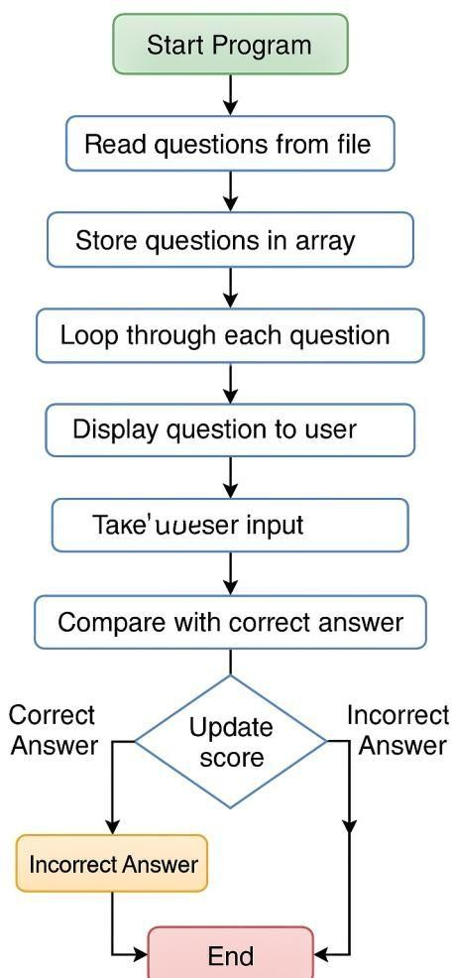

CHAPTER 3: RESULTS ANALYSIS AND VALIDATION
3.1 Implementation of Solution
The implementation of the Online Quiz System was carried out using core Java, following a modular and object-oriented approach. The system consists of several classes that manage different functionalities such as loading questions, capturing user input, evaluating answers, and displaying results. Questions and their multiple-choice options are stored in an external text file, which is read during runtime using Java’s file I/O mechanisms. This allows for easy modification of quiz content without altering the source code. Arrays and custom objects are used to store and manage questions and user responses efficiently, ensuring smooth navigation through the quiz.
User interaction is handled through a simple console interface, where users are prompted to enter their answers by selecting the correct option number. The program performs validation on the input and maintains a running score as the quiz progresses. At the end of the quiz, the total number of correct answers is displayed along with the percentage score, providing immediate feedback to the user. The implementation also includes error handling techniques to prevent the system from crashing due to incorrect input or file-related issues.
To maintain clarity and modularity, the code is divided into multiple classes—such as Question, QuizManager, and Main—each responsible for a specific task. This approach not only ensures cleaner code but also makes it easier to expand or maintain the system in the future. Although the primary version is console-based, the system architecture allows for GUI enhancement using Java Swing, which could be added later without major restructuring. Overall, the solution was implemented in a way that reflects good programming practices, while still being accessible for beginner-level developers.
Figure 3.2 – Code snippet for file reading and answer checking
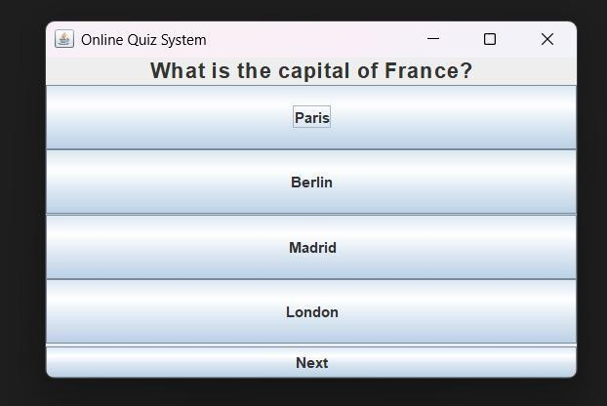
Fig 1: Question 1
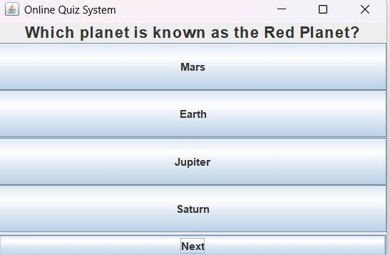
Fig 2: Question 2
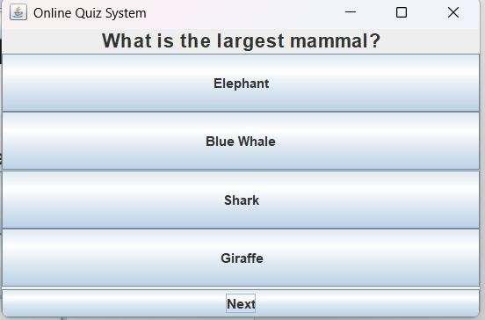
Fig 3: Question 3
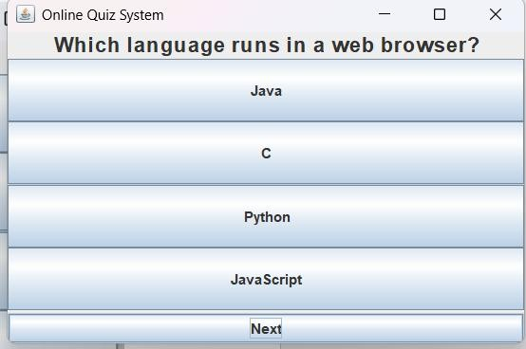
Fig 4: Question 4
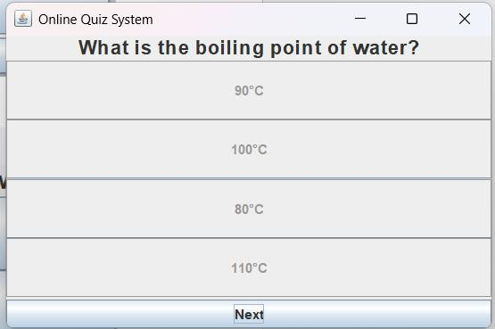
Fig 5: Question 5
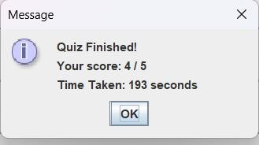
Fig 6: Quiz Score

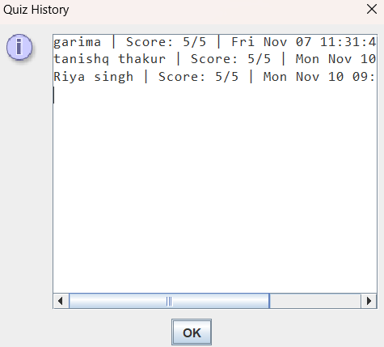

CHAPTER 4: CONCLUSION AND FUTURE WORK
4.1 Conclusion
The development of the Online Quiz System in Java has been a highly educational and rewarding experience. It successfully demonstrates the practical application of core programming concepts such as Object-Oriented Programming (OOP), File
Input/Output (I/O), arrays, and user interaction handling. These elements are essential for any aspiring Java developer, and this project brings them together in a structured and meaningful way.
The system was initially designed with simplicity, usability, and educational value in mind. Its primary objective was to allow users to take a multiple-choice quiz through an interface that is both intuitive and efficient. The console-based implementation provides a basic yet effective way for users to interact with the quiz, making it an ideal starting point for beginners to understand program flow, user input validation, and conditional logic.
One of the most notable aspects of the system is its ability to read quiz questions from an external file. This feature introduces the concept of persistent storage and dynamic data loading, which are critical for real-world applications. Instead of hardcoding questions, the system loads them at runtime, stores them in structured Java objects (such as instances of a Question class), and displays them sequentially to the user. This modular design ensures flexibility, as questions can be easily added, removed, or modified without changing the underlying code.
The use of object-oriented programming played a major role in the successful organization of the project. By separating responsibilities into distinct classes like Question, QuizManager, and possibly User, the system becomes easier to understand, debug, and extend. Concepts like encapsulation, abstraction, and modularity were applied effectively to keep the codebase clean and maintainable. This approach also sets a strong foundation for future improvements, such as incorporating a graphical user interface (GUI) or connecting the system to a database.
Beyond technical implementation, this project also significantly contributed to the development of soft skills such as logical thinking, problem-solving, time management, and structured planning. While working on different components of the system—such as question validation, score calculation, and user feedback—the need for careful design and efficient implementation became evident. These experiences mirror real-world software development practices, making the project a valuable stepping stone for future academic or professional work.
Moreover, the system was designed with extensibility in mind. While the current version is console-based, the project can easily be enhanced by integrating Java Swing to build a GUI version. This would improve user experience and introduce learners to event-driven programming and layout management. Additional enhancements such as implementing a timer, randomizing questions, saving results to a file, adding user authentication, or integrating a database like MySQL can make the system more robust and applicable in real educational or corporate training environments.
In conclusion, the Online Quiz System is more than just a basic Java project—it is a comprehensive educational tool that brings together theoretical concepts and practical skills. It meets its initial objectives while offering numerous opportunities for future upgrades. As a beginner-level application, it is ideal for students learning Java, and with further development, it has the potential to become a feature-rich, scalable, and user-friendly quiz platform suitable for broader academic and professional use.
4.2 Future Work
While the current version of the Online Quiz System serves as a successful demonstration of core quiz functionalities, there remains substantial scope for enhancement to make it more dynamic, interactive, and aligned with real-world use cases. These improvements, if implemented in future iterations, can significantly increase the system’s usability, scalability, and overall impact.
One of the most important enhancements would be the integration of a Graphical User Interface (GUI) using Java Swing or JavaFX. While the console-based interface is functional and suitable for beginners, a GUI would provide a more engaging and visually appealing user experience. Components such as buttons, radio buttons, text fields, progress bars, and dialog boxes can be used to create a more intuitive and professional interface. It would also introduce learners to event-driven programming, layout design, and GUI component management, thereby expanding their development skills.
In addition to GUI implementation, incorporating a timer feature can simulate realtime test scenarios. Each question could have an individual timer, or the entire quiz could be time-bound, depending on the quiz type. This would make the system suitable for competitive examinations or assessments, where time management is critical. Moreover, time tracking can be used to generate performance analytics, allowing users to evaluate their speed and accuracy under pressure.
Another effective upgrade would be the randomization of questions and options. Currently, questions appear in a fixed order, which may lead to predictability. Randomizing the sequence of questions and shuffling the answer choices would make each quiz attempt unique, reducing the chances of memorization and encouraging genuine knowledge evaluation. This approach also helps in maintaining fairness during tests administered to multiple users simultaneously.
To make the system multi-user friendly, user login and authentication features can be added. By allowing users to register, log in, and take quizzes under their own accounts, the application can store and differentiate between individual user results. This feature opens the door to personalized dashboards, performance tracking, and user-specific feedback. A secure login system would also make the platform more suitable for classroom or institutional use.
In terms of data management, a major improvement would be the integration of a relational database such as MySQL or SQLite. This would replace the current filebased storage method and allow for more robust and scalable data handling. A database would efficiently manage user records, questions, scores, feedback, and login credentials. It would also make it easier to handle large volumes of data and support advanced queries for analytics and reporting.
Furthermore, the system can be enhanced to support multiple quiz categories or subjects. Users could select from different topics like Science, History, Technology, etc., depending on their interest or learning objectives. Each category could have a separate question bank, making the system more flexible and adaptable for various academic and training environments.
Introducing an admin panel is another valuable addition. This interface would allow educators or moderators to add, edit, or delete quiz questions, set time limits, and manage user roles without directly modifying the source code or accessing the file/database manually. This feature would make the system manageable by nontechnical users, increasing its applicability in educational institutions.
Additional enhancements could include generating graphical score reports, exporting results to PDF, maintaining leaderboards, and even providing hints or explanations for correct answers. Such features would not only elevate the user experience but also enhance learning and engagement.
In conclusion, by implementing these future enhancements, the Online Quiz System can evolve from a simple educational tool to a comprehensive quiz platform. These upgrades will make the system more dynamic, scalable, and suitable for real-world academic and professional training environments.

References:
https://www.javatpoint.com/online-quiz-project https://docs.oracle.com/javase/8/docs/api/ https://www.geeksforgeeks.org/java-swing/ https://www.javatpoint.com/java-awt-event-listener https://www.w3schools.com/java/java_files.asp https://stackoverflow.com/

